Meteorology
Chapter 2
Air
Air comes in air masses like tropical maritime these affect the weather in these regions a lot. The air mass near the uk is a cold humid mass and so we get a lot of rain and shower systems because it is above a warm and humid mass creating a lot of systems on the edge between europe and the uk and up north towards the middle of the air mass a lot of systems are created.

This is why the rain seems to always be here in the uk it comes in systems wave after wave when two boundries meet between europe and the uk there is a massive drop in temperature and the warm air rises like this and this will probbaly create a situation with clouds rising and showers and possibly thunderstorms. 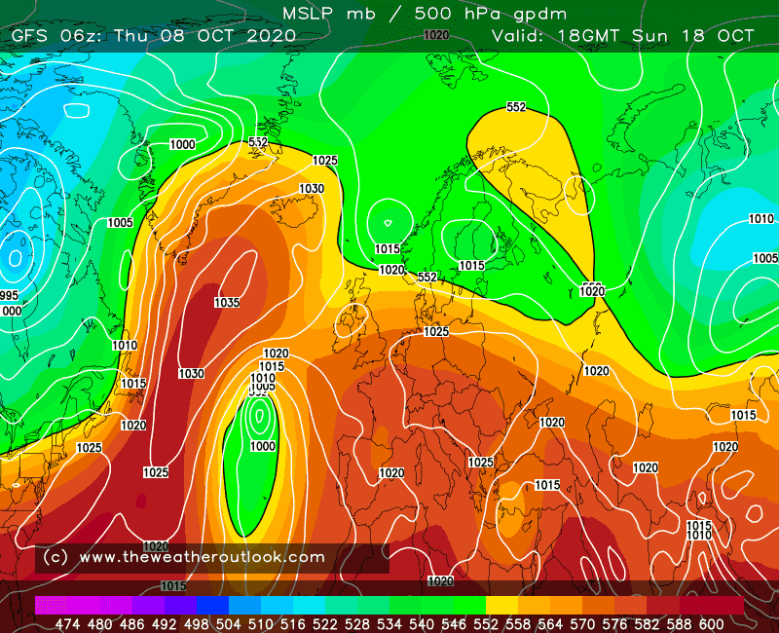The arm air rises above the cold air much like the cumulonimbus clouds or storm clouds these create an instibility creating a rise in air and clouds and o a mutilayer cloud.

